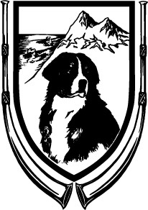

THE

BERNESE

MOUNTAIN

DOG

CLUB

OF

SOUTHERN

CALIFORNIA,

INC.

27
TH

ANNUAL

SWISS

BREEDS

MATCH

2021

Lunch Order Form

We are offering three “box” lunch sandwich options and two salads for purchase.
Each sandwich comes with fresh fruit, a pasta salad and a cookie:
Roast Beef & Cheddar Sandwich | Turkey Avocado Sandwich | The Veggie Sandwich
Thin sliced Roast Beef  Cheddar Cheese  Lettuce  Tomato  On a French Roll | Roasted Turkey Breast  Sliced Avocado  Swiss Cheese  Lettuce  Tomato with Light Mayonnaise  On a Butter Croissant | Avocado  Provolone Cheese  Cucumber  Pepperoncini  Tomato, Lettuce, Pickles & Olives  On a French Roll

For the lighter appetite, we are offering two large salads that are each a la carte:
Stefano’s Salad | Bella Donna Salad
Romaine Lettuce, Roasted Chicken, Feta Cheese, Bacon, Black Olives, Tomatoes, Artichoke Hearts, Pepitas, Topped with freshly grated Parmesan, Croutons, & Served with Balsamic Vinaigrette | Mixed fresh greens, sun-dried cranberries, seasonal fruits, goat cheese, cherry tomatoes, candied walnuts, with champagne vinaigrette

All lunches are $13 and will be delivered mid-day at the Match; lunch orders must be received by Saturday,
October 16, 2021 by Patti Grijalva. Make checks payable to BMDCSC Inc. and submit lunch order with payment to Patti Grijalva, 23 Rolling Hills, Coto de Caza, CA 92679

Lunch Order
Item | Quantity
The Beef Box
The Turkey Box
The Veggie Box
Pasta Spring Salad
Bella Donna Salad
Total Quantity

Total
Quantity x $13

